Overview:
The objective of this project is to design and implement a sequential 4-bit Arithmetic ALU. The system processes two- 4bit inputs (A and B) to perform logical, arithmetic, and sequential operations based on a user defined operational code. The final result is processed and displayed on a single 7-segment display in hexadecimal/decimal format.
System inputs:
- Operand A (4-bit): Primary data input.
- Operand B (4-bit): Secondary data input.
- OpCode (4-bit): Control signals to select a particular operation.
- Clock (CLK): Synchronization signal for sequential operations (like counters/shifters).
- Reset (RST): Global reset to initialize the system.
- Enable: Active signal to enable/disable operations.

System Outputs:
- ALU Result (4-bit): The binary output of the selected operation.
- 7-Segment Signals (7-bit): Decoded signals (A-G) to drive the display.

Design Scope:
The design includes both combinational logic (arithmetic operations) and sequential logic (for counters and shift registers). The system is designed to be synthesized on DE1-SoC with Altera.

Operations
AND, Op=0000
A | B | Output
0000 | 0000 | 0000
0101 | 0011 | 0001
1100 | 1010 | 1000
1111 | 0111 | 0111
1111 | 1111 | 1111
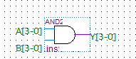

OR, Op=0001
A | B | Output
0000 | 0000 | 0000
0101 | 0011 | 0111
1100 | 1010 | 1110
1000 | 0100 | 1100
1111 | 0000 | 1111
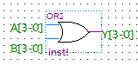
XOR, Op=0010
A | B | Output
0000 | 0000 | 0000
0101 | 0011 | 0110
1100 | 1010 | 0110
1111 | 1111 | 0000
1001 | 0110 | 1111
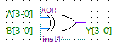

INV, Op=0011
A | B | Output
0000 | XXXX | 1111
0001 | XXXX | 1110
0101 | XXXX | 1010
1010 | XXXX | 0101
1111 | XXXX | 0000
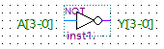

ADD, Op=0100
A | B | Output
0000 | 0000 | 0000
0011 | 0101 | 1000
0111 | 1000 | 1111
1001 | 0100 | 1101
4-bit Adder
A
Sum
B

CMP, Op=0101
A | B | Output | L, A<B | E, A=B | G, A>B
0101 | 0101 | 0010 | 0 | 1 | 0
0011 | 1000 | 0100 | 1 | 0 | 0
1010 | 0101 | 0001 | 0 | 0 | 1
0000 | 1111 | 0100 | 1 | 0 | 0
0000 | 0000 | 0010 | 0 | 1 | 0
A
Comparator
L,E,G
B

ODD, Op=0110
A | B | Output
0000 | XXXX | 0000
0001 | XXXX | 0001
0010 | XXXX | 0000
0011 | XXXX | 0001
0100 | XXXX | 0000
A
IsOdd
Odd

EVEN, Op=0111
A | B | Output
0000 | XXXX | 0001
0001 | XXXX | 0000
0010 | XXXX | 0001
0011 | XXXX | 0000
0100 | XXXX | 0001
IsEven
Even
A

SHL, Op=1000
A | B | Output
0001 | XXXX | 0010
0010 | XXX | 0100
0100 | XXX | 1000
0101 | XXX | 1010
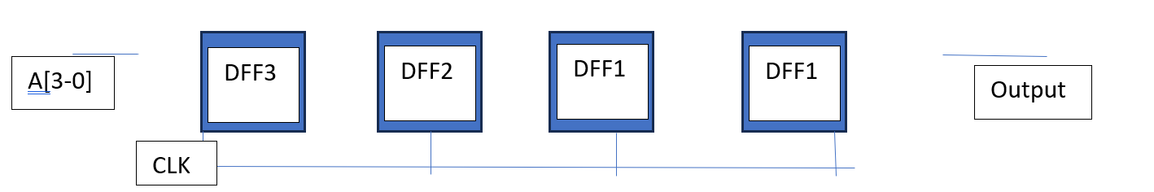
Shift

SHR, Op=1001
A | B | Output
1000 | XXXX | 0100
0100 | XXXX | 0010
0010 | XXXX | 0001
1111 | XXXX | 0111
Shift
DFF1
DFF1
DFF2
DFF3
Output
A[3-0]

CLK

Counter, Op=1010
A | B | DIR | Output[1-3]
0000 | XXXX | Up | 1, 2, 3
0101 | XXXX | Up | 6, 7, 8
1010 | XXXX | Down | 9, 8, 7
0000 | XXXX | Down | 15, 14, 13
CLK
4-bit
Counter
DIR
EN
Input
RST
Output

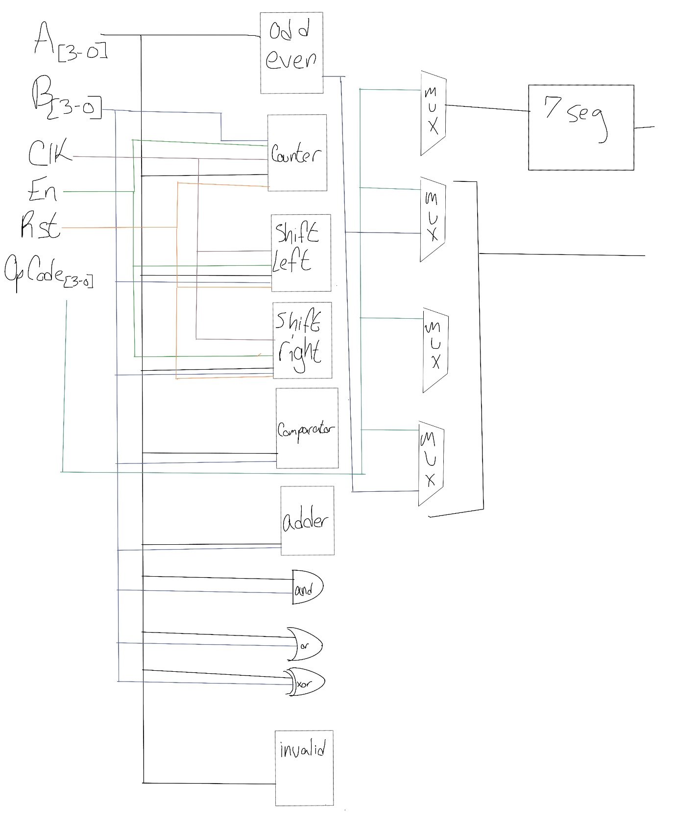

Fig: Block Diagram

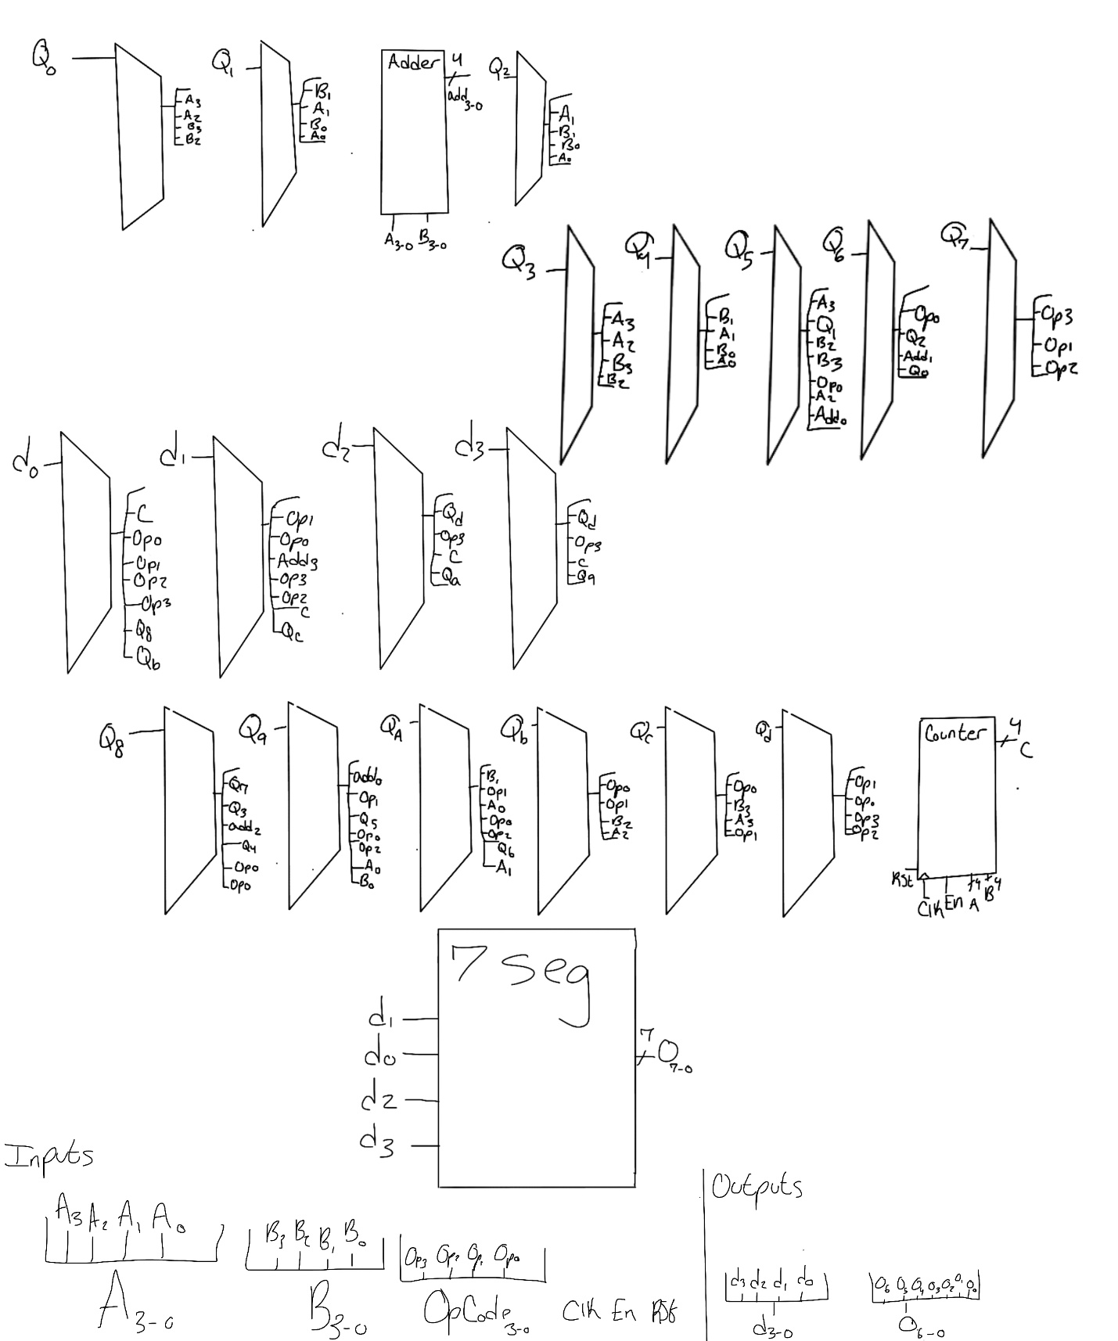
Fig: Internal Schematic diagram

Circuit Diagram: (From Quartus RTL viewer)
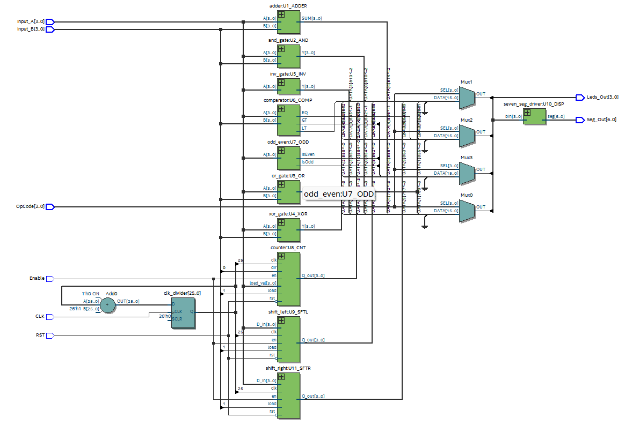

The Operation Table:
OpCode | Operation | Type | Description
0000 | AND | Combinational | Bitwise AND of A and B
0001 | OR | Combinational | Bitwise OR of A and B
0010 | XOR | Combinational | Bitwise XOR of A and B
0011 | INV (NOT) | Combinational | Bitwise Inversion of A
0100 | ADD | Combinational | Arithmetic Addition (A + B)
0101 | COMPARE | Combinational | Checks if A>B, A=B, or  A<B
0110 | IsOdd | Combinational | Checks parity of A  (Returns 1 if Odd)
0111 | IsEven | Combinational | Checks parity of A (Returns 1 if Even)
1000 | Shift Right | Sequential | Shift Right
1001 | Shift Left | Sequential | Shift Left
1010 | Counter | Sequential | Counts Up/Down starting at input value

Thought process behind the code:
- AND Gate
This module performs a bitwise AND between two 4-bit inputs. Each bit of A is compared with the corresponding bit of B, and the output only goes high if both bits are 1. It is fully combinational and directly expresses the hardware behavior of the AND operation over a vector.

- OR Gate
This is the same structural idea as the AND gate, but it implements bitwise OR. For each bit position, the output becomes 1 if at least one of the input bits is 1. Again, purely combinational and straightforward.

- XOR Gate
This module applies the bitwise XOR operation, which outputs 1 when the bits differ. The architecture is minimal because VHDL naturally supports vector-wise XOR.

- NOT (Inverter) Gate
Each bit of the 4-bit input vector is inverted. It is a simple unary NOT operation and flips all the bits simultaneously. This module is useful for sign inversion, bit masking, or general logic manipulation.

- 4-bit Adder with Overflow
This module implements a 4-bit unsigned adder. The key detail is the use of an internal 5-bit signal (result) created by zero-extending A and B before addition. This ensures correct arithmetic and makes overflow detection easy.
The lower 4 bits become the SUM output, while the 5th bit (the carry-out) is exposed as the overflow flag. This is a clean and synthesizable way of handling arithmetic with overflow reporting.
- Comparator
This block compares two 4-bit values and asserts one of three flags:
GT (greater than), EQ (equal), LT (less than)
To make the comparison mathematically valid, both inputs are first cast into the unsigned type. Only one of the three outputs will be high at any moment, making this a very deterministic and readable comparison unit.
- Odd/Even Checker
This is a lightweight module that checks parity based on the least significant bit. In binary, the LSB determines oddness: If A(0) = 1 -> the number is odd
If A(0) = 0 -> the number is even
This makes the implementation extremely simple and fast.
- 4-bit Up/Down Counter with Load and Reset
This is one of the more dynamic modules in the collection. It contains a 4-bit register implemented as an unsigned signal. The behavior is controlled on the rising edge of the clock: Reset (rst = 1): clears the counter to zero, Load (load = 1): directly loads a custom 4-bit value, Enable (en = 1): allows counting, Direction (dir):
0 count up, 1 -> count down
9. Seven-Segment Display Driver
This module converts a 4-bit binary input into the segment pattern required to show hexadecimal digits (0–F) on a seven-segment display.
It uses a simple combinational case statement, mapping each 4-bit code to its corresponding LED pattern. This is the standard way to drive seven-segment displays and ensure clean decoding.

Sequential Operations:
- Shift Operations: On the rising edge of the clock:
  - Shift Right: Qi <- Qi+1, with Q3 <- 0.
  - Shift Left: Qi <- Qi-1, with Q0 <- 0.
- Bidirectional counter:
  - When Load = 1: The counter is initialized to the value of Input A.
  - When Enable = 1: The counter increments or decrements (based on direction signal) on the easing clock edge.

10. Shift Left
This unit performs a logical left shift by one position. The leftmost bit is dropped, every bit shifts one position left, and zero is inserted at the rightmost position. This can be used for multiply-by-2 operations or bit-level manipulation.
11. Shift Right
This is the mirror image of the left shifter. It performs a logical right shift, inserting a zero on the left and moving every bit one position to the right. This is commonly used for divide-by-2 operations or serial data processes.
12. ALU top module
This module is the top-level system that brings together all of my individual components i.e., logic gates, arithmetic units, comparison modules, shifting blocks, a counter, and a seven-segment display driver, into one unified 4-bit ALU. This design takes two 4-bit inputs, an opcode, and a few control signals, and then performs one of several operations depending on the selected opcode.

Simulation verification:
And Operation
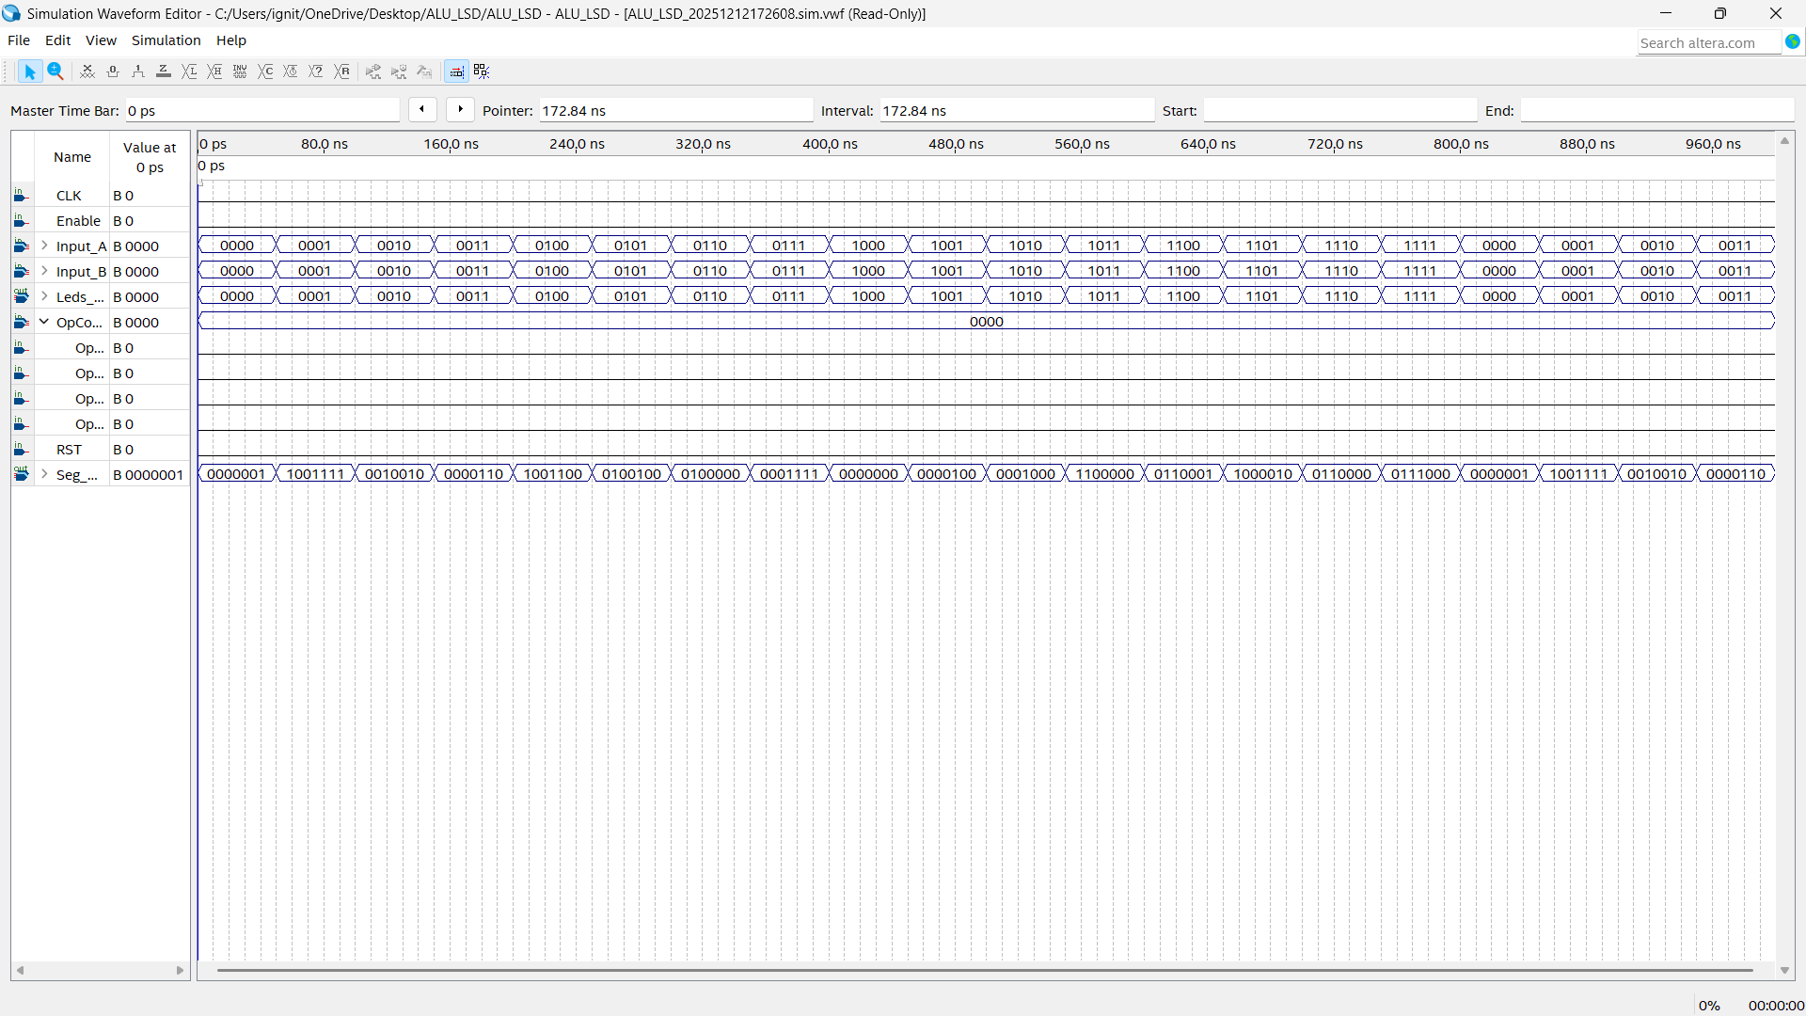
Fig: Waveform simulation of AND operation
Or Operation
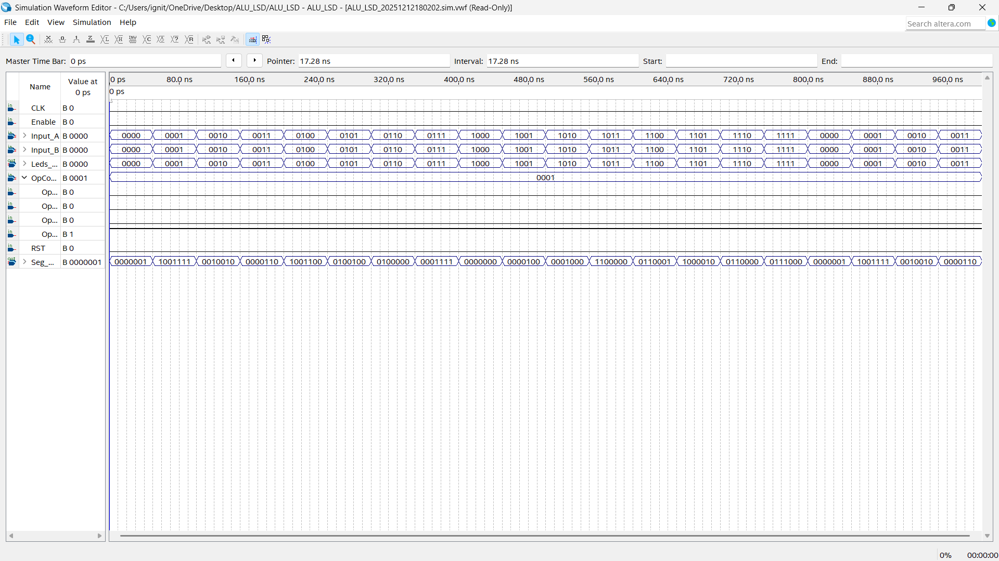
Fig: Waveform simulation of OR operation
XOR operation
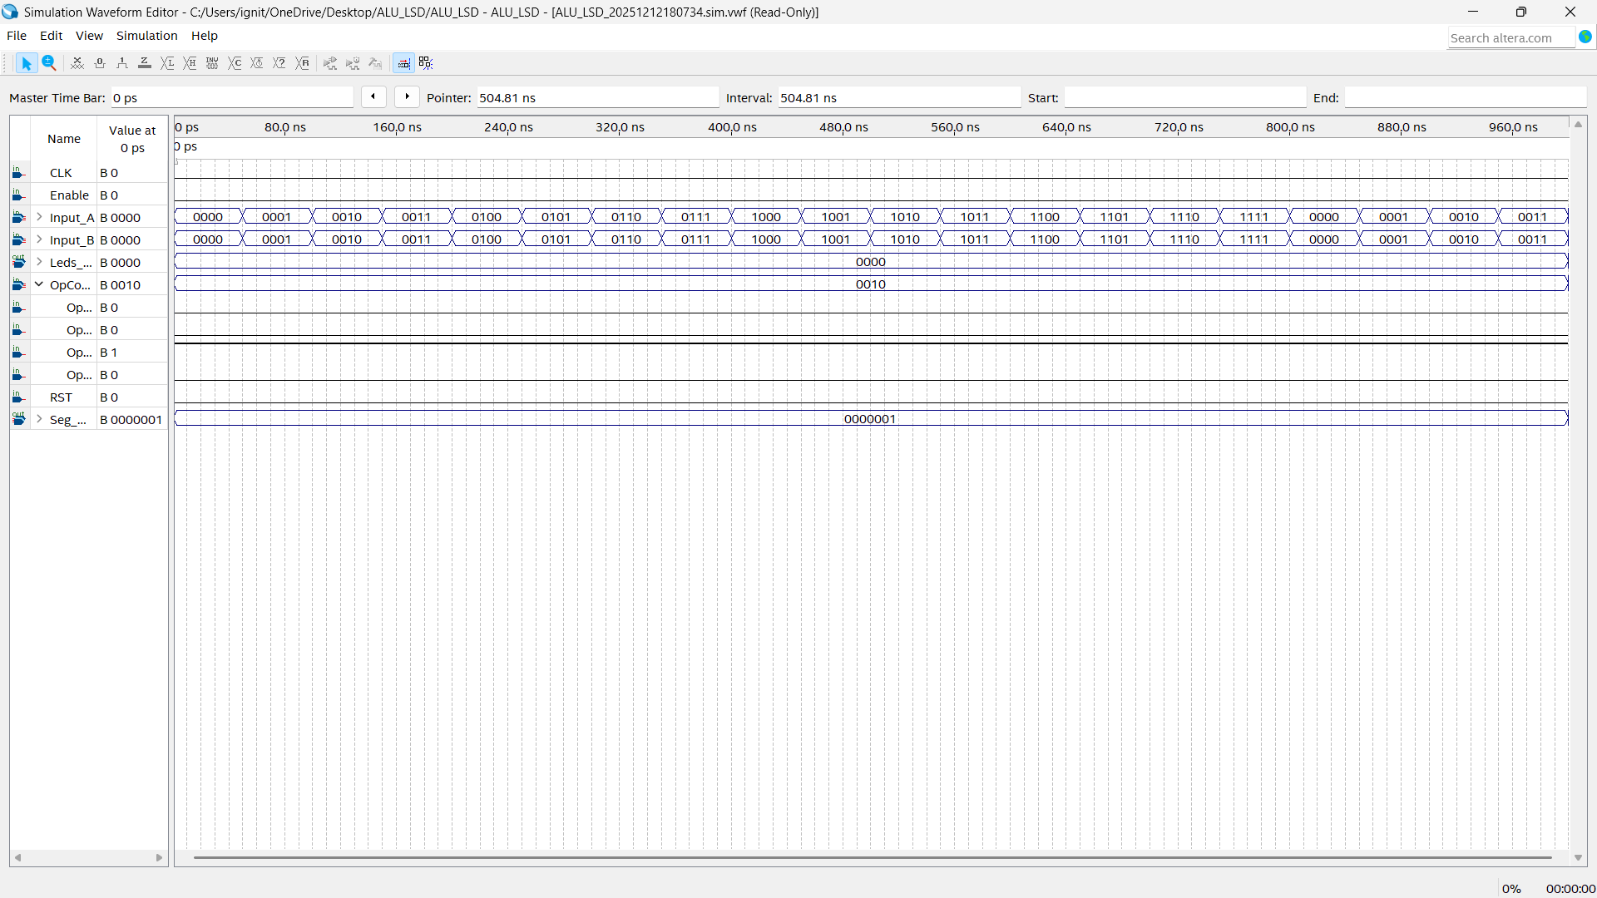
Fig: Waveform simulation of XOR operation
INV operation
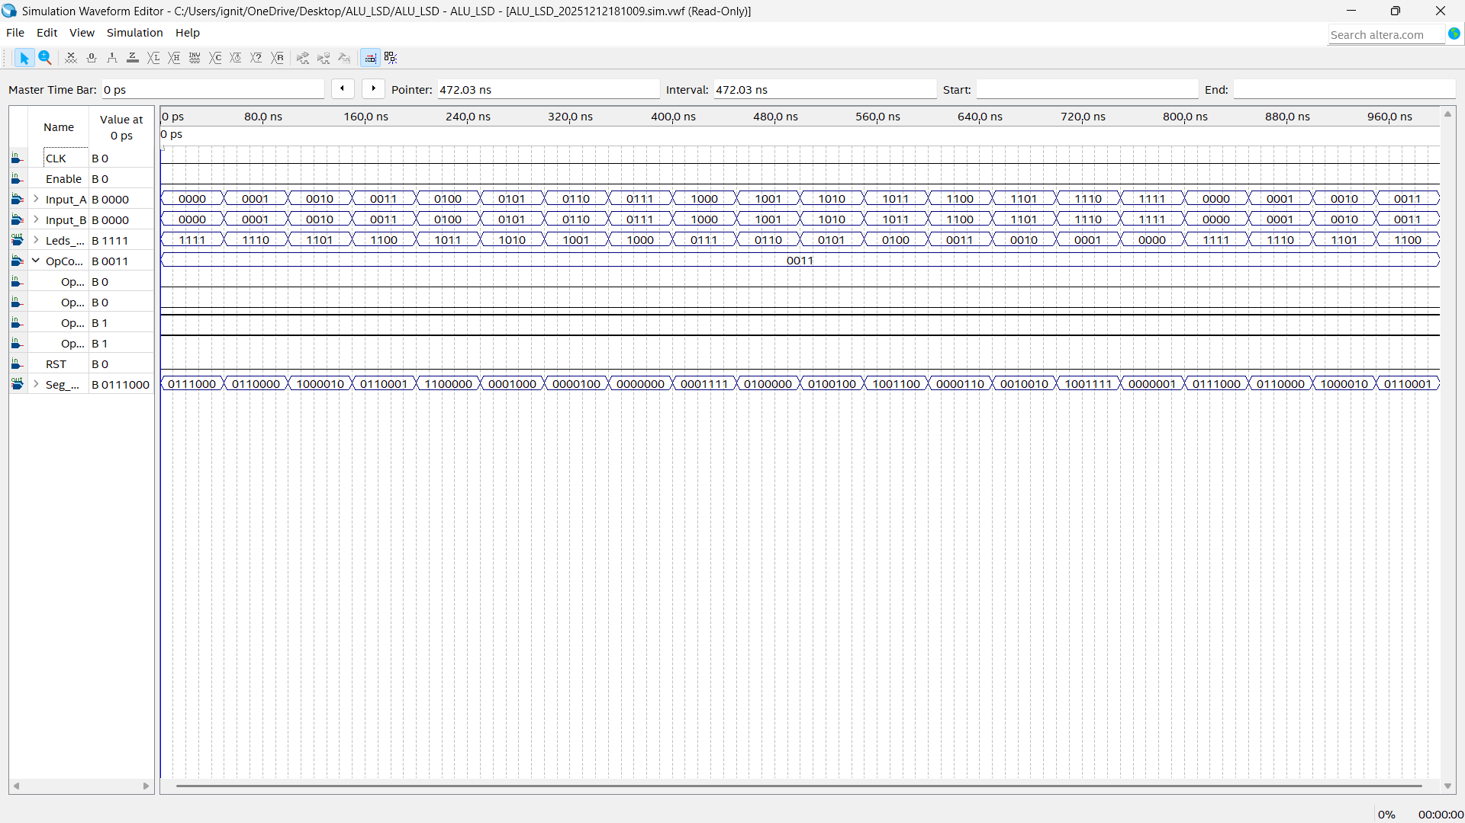
Fig: Waveform simulation of INV operation
ADD Operation
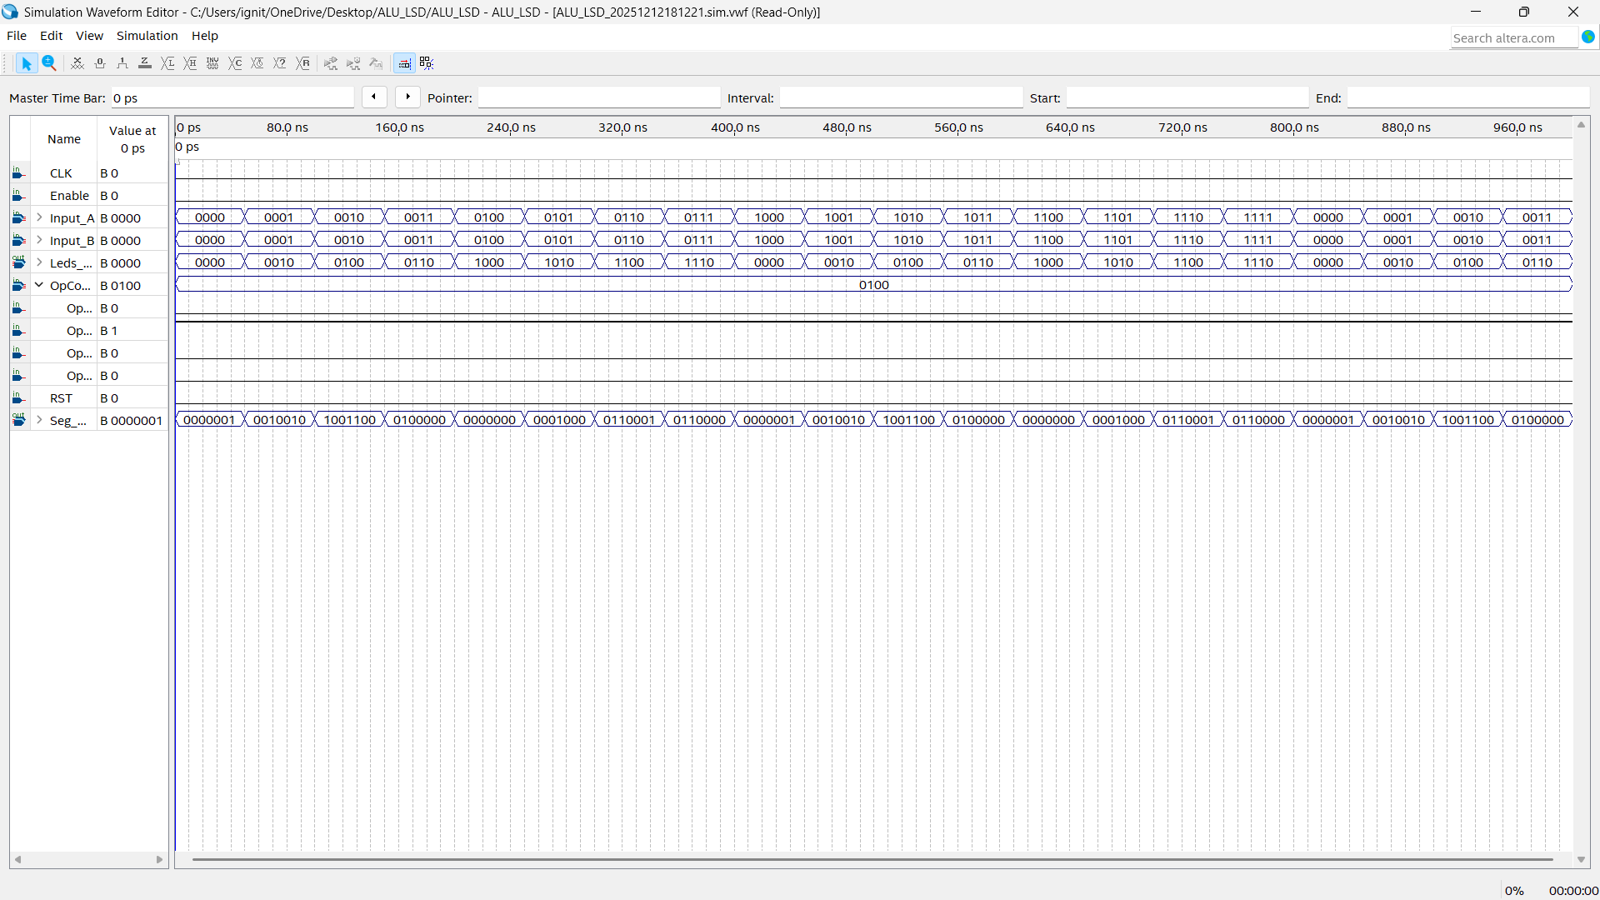
Fig: Waveform simulation of ADD operation
COMPARE Operation
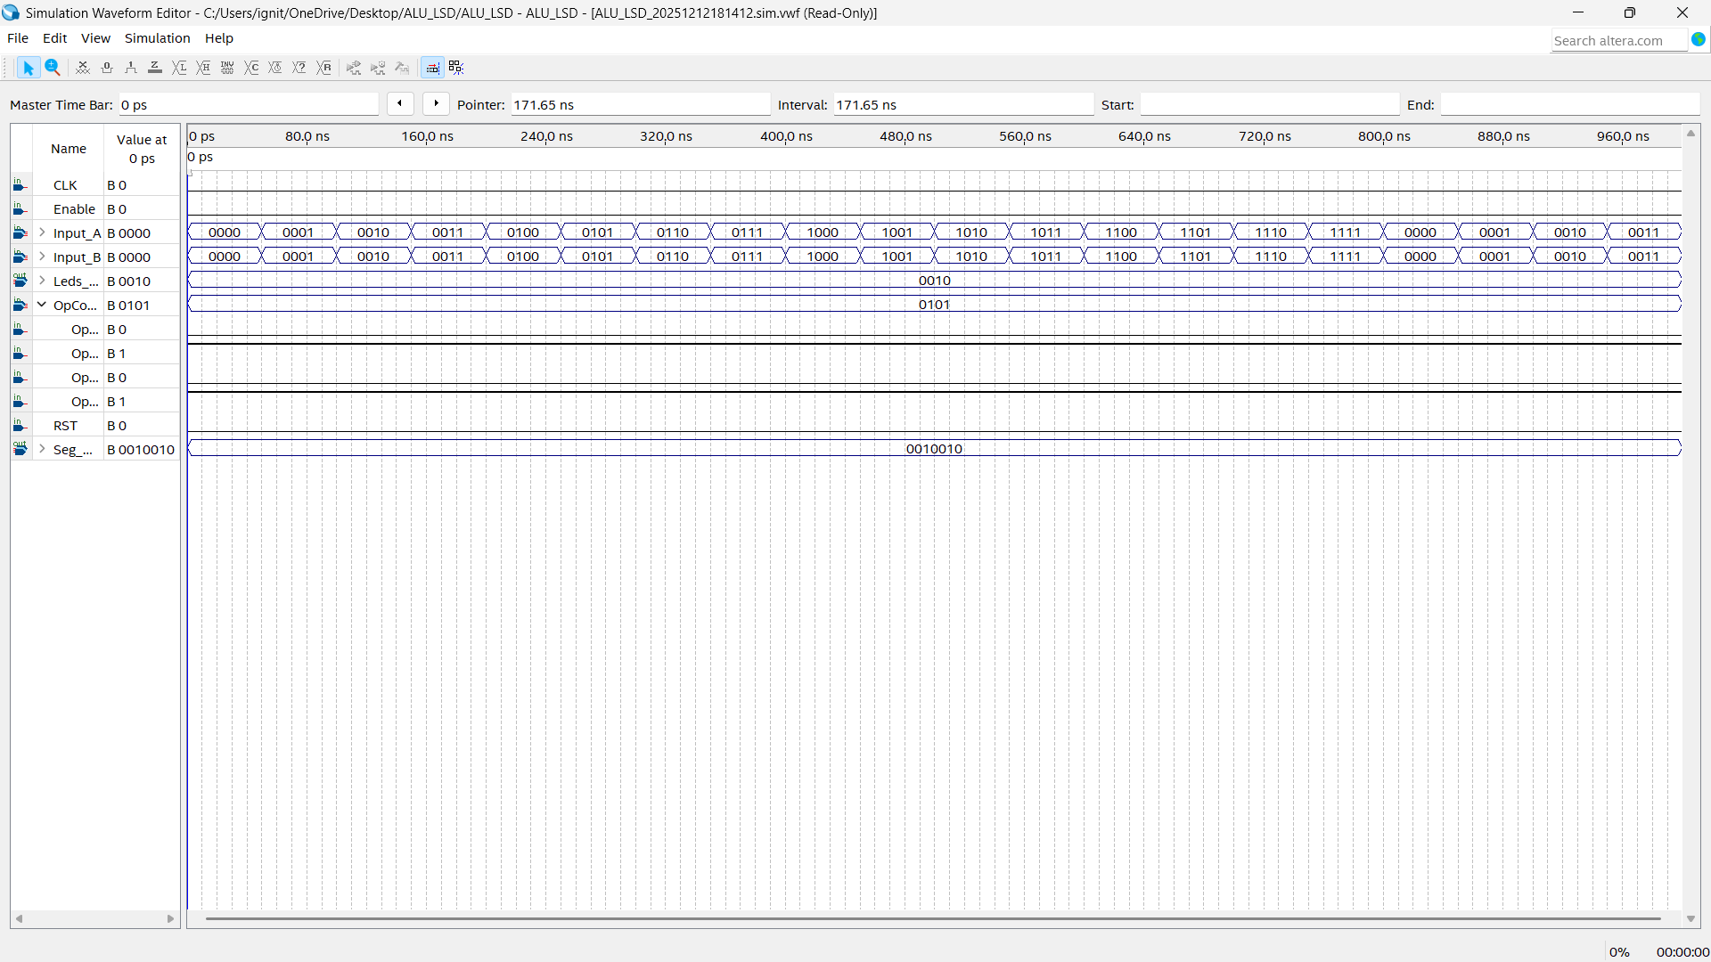
Fig: Waveform simulation of COMPARE Operation
IsODD Operation
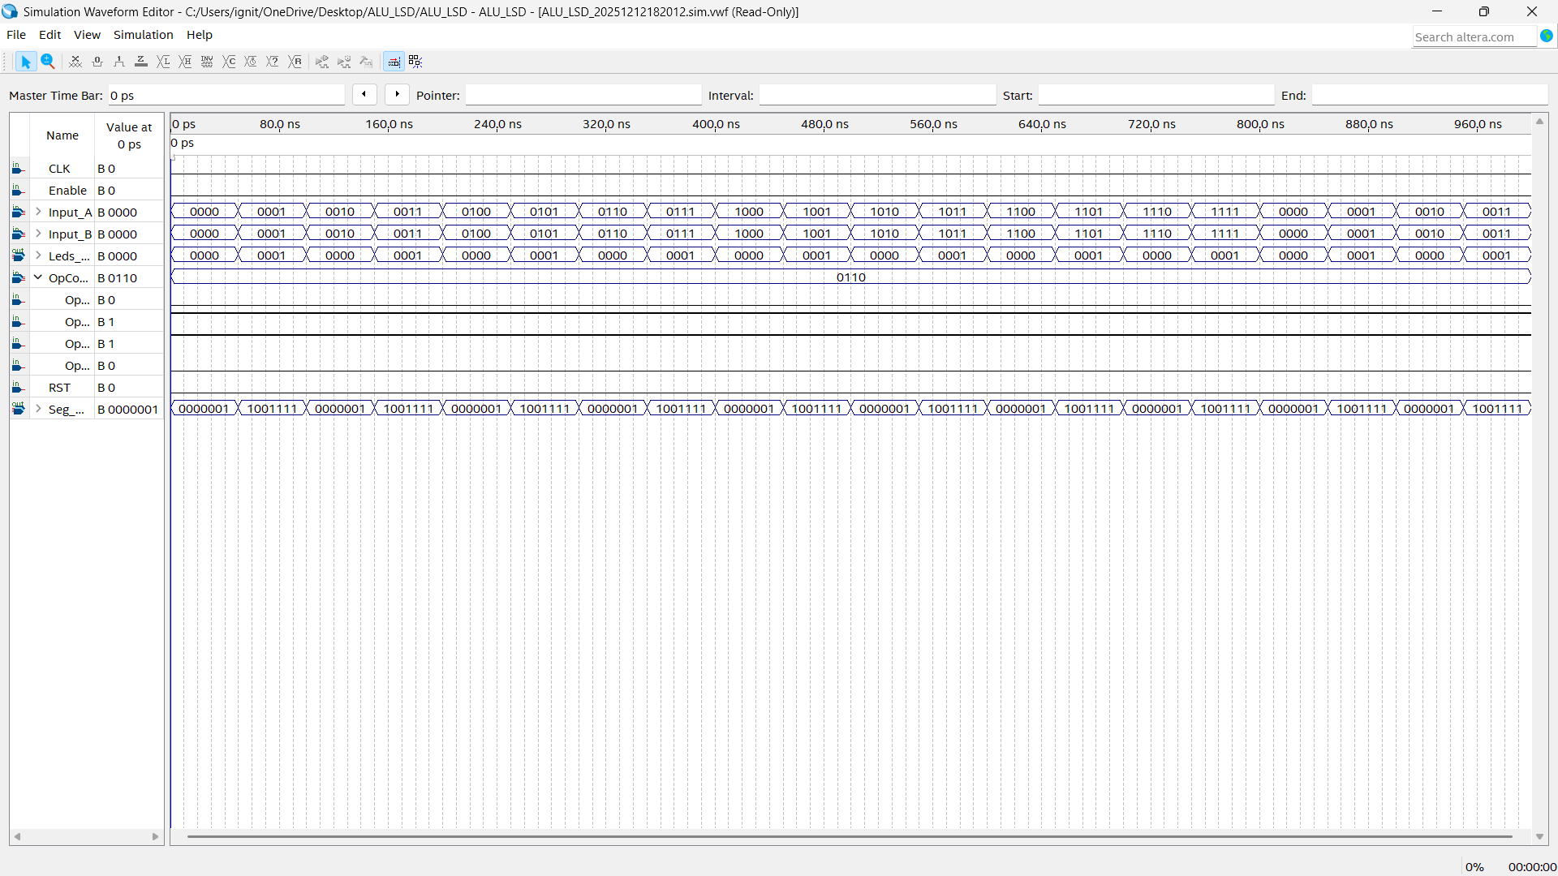
Fig: Waveform simulation of IsODD Operation
IsEVEN Operation
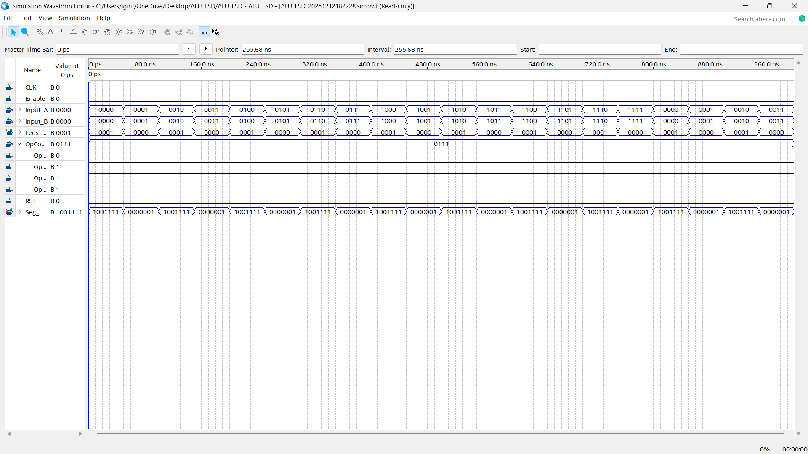
Fig: Waveform simulation of IsEVEN Operation
Shift Left Operation
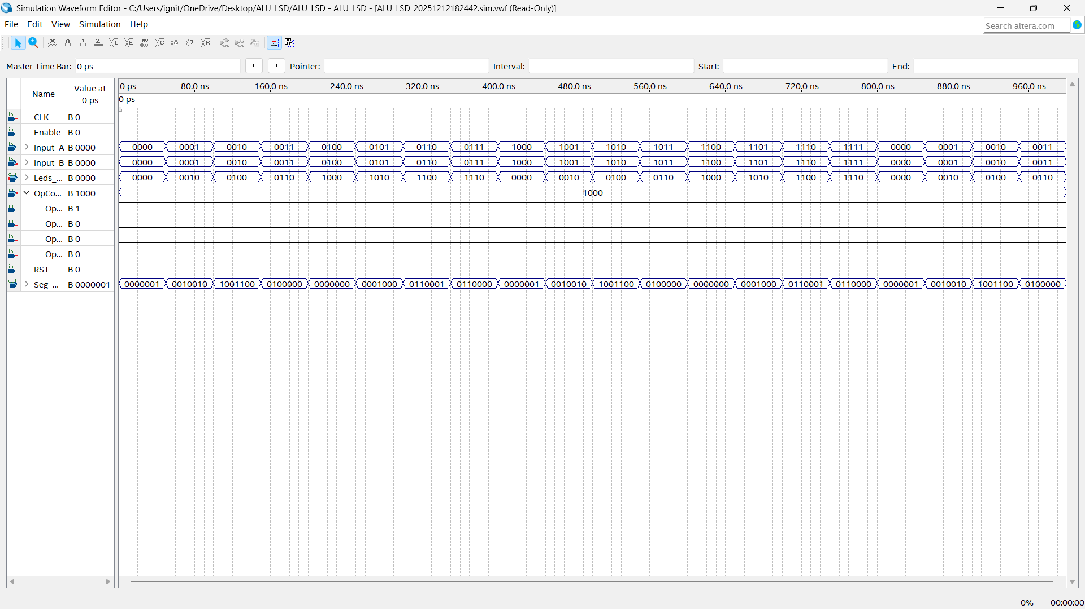
Fig: Waveform simulation of Shift Left Operation
Shift Right Operation
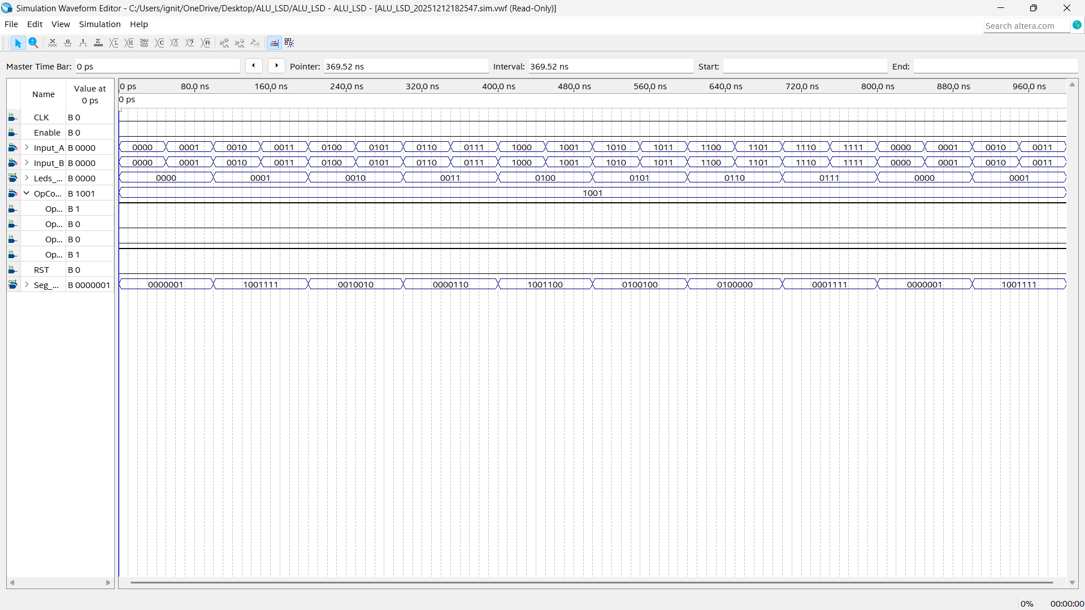
Fig: Waveform simulation of Shift Right Operation

Counter Operation
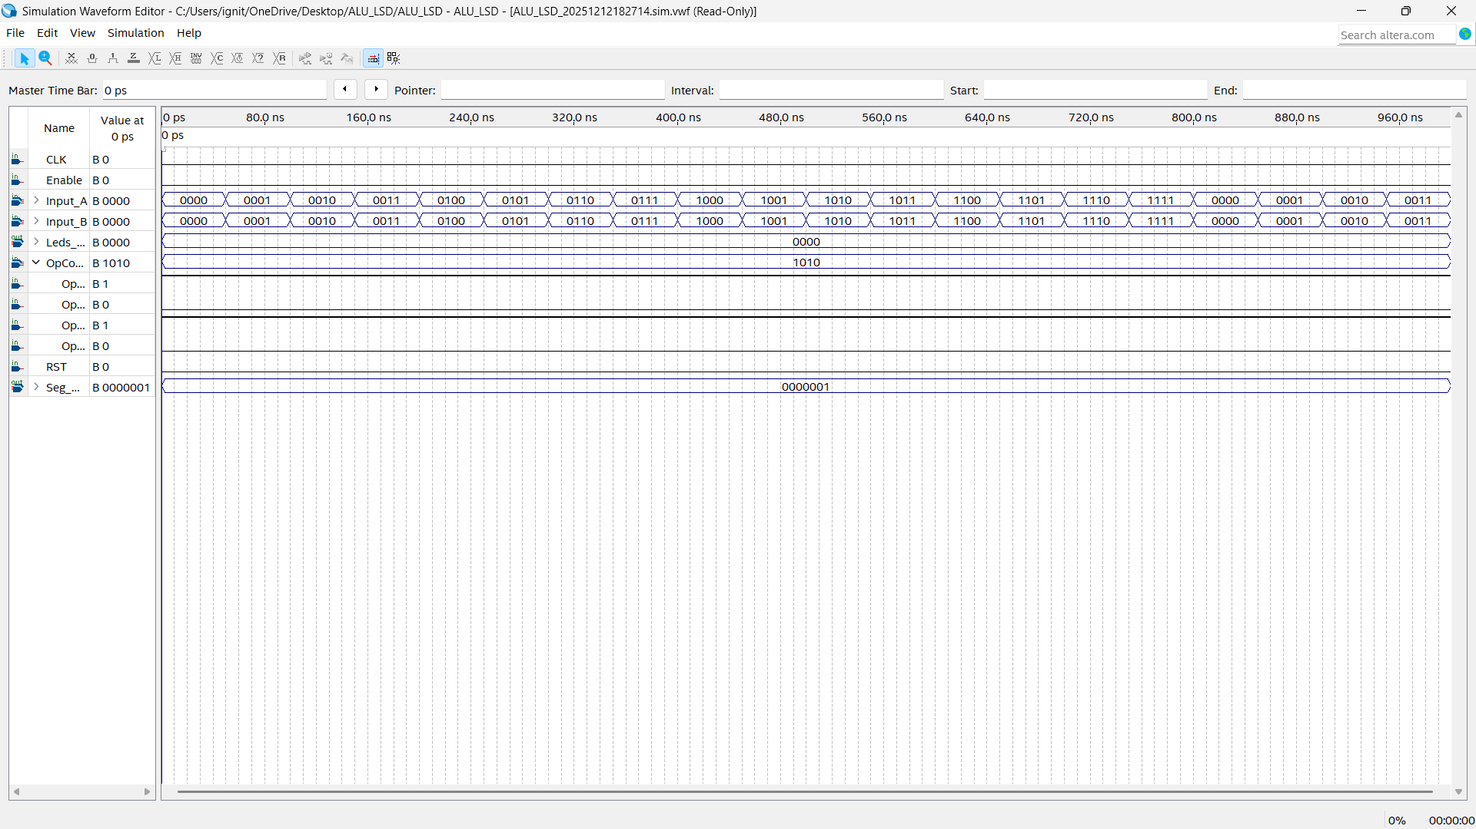

Fig: Waveform simulation of Counter Operation

Pin planner:
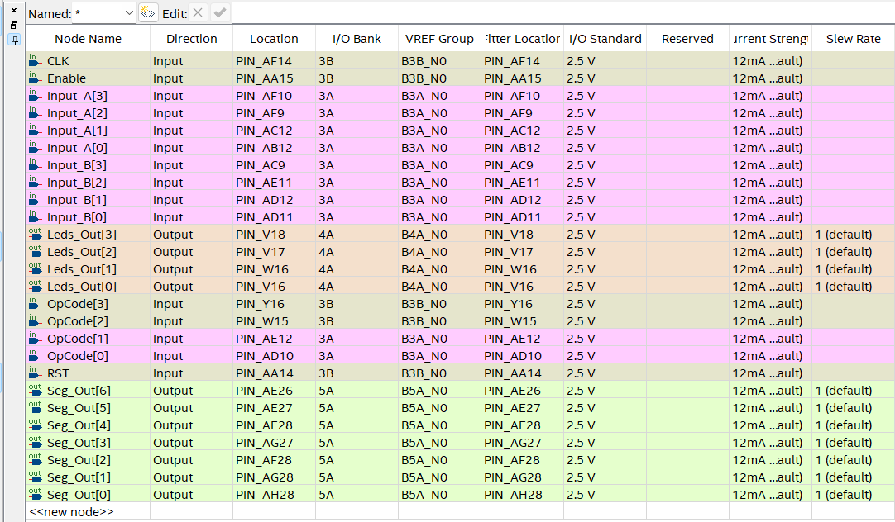

Test cases:
Inputs |  |  | Expected Outputs |  | Outputs Acquired |  | Matching
A | B | OpCode / Operation | Result (Bin) | 7-Segment Pattern | Result | 7-Segment Pattern | (YES/NO)
101 | 11 | 0000 (AND) | 1 | "1" | 1 | 1 | Yes
101 | 11 | 0001 (OR) | 111 | "7" | 111 | 7 | yes
101 | 11 | 0010 (XOR) | 110 | "6" | 110 | 6 | Yes
101 | XXXX | 0011 (INV) | 1010 | "A" | 1010 | A | Yes
110 | 10 | 0100 (ADD) | 1000 | "8" | 1000 | 8 | Yes
101 | 101 | 0101 (CMP) | 10 | "2" | 10 | 2 | Yes
111 | XXXX | 0110 (IsOdd) | 1 | "1" | 1 | 1 | Yes
100 | XXXX | 0111 (IsEven) | 1 | "1" | 1 | 1 | Yes
11 | XXXX | 1000 (Shift Left) | 110 | "6" | 110 | 6 | Yes
1000 | XXXX | 1001 (Shift Right) | 100 | "4" | 100 | 4 | Yes
10 | XXXX | 1010 (Counter) | 11 | "3" | 11 | 3 | Yes

Task Distribution:

Task Title | Student | Detailed Contribution | Contribution
Operation AND | Shreya Pandey | Handled entire operation | 100
Operation OR | Shreya Pandey | Handled entire operation | 100
Operation XOR | Shreya Pandey | Handled entire operation | 100
Operation INV | Shreya Pandey | Handled entire operation | 100
Operation ADD | Shreya Pandey | Handled entire operation | 100
Operation Compare | Shreya Pandey | Handled entire operation | 100
Operation IsOdd | Shreya Pandey | Handled entire operation | 100
Operation IsEven | Shreya Pandey | Handled entire operation | 100
Operation Shift Right | Shreya Pandey | Handled entire operation | 100
Operation Shift Left | Shreya Pandey | Handled entire operation | 100
Operation Counter | Shreya Pandey | Handled this operation with debugging help | 80
 | Anna Rivenbark | Helped Debug the counter operation | 20
Top level module and Implementation | Shreya Pandey | Handled entire operation | 100
Integration and testing | Shreya Pandey | Handled entire operation | 50
 | Anna Rivenbark | Handled the verification and accuracy | 50
Design of testcases | Shreya Pandey | Handled the entire operation | 100
Final Report Documentation | Shreya Pandey | Worked on the documentation | 50
 | Anna Rivenbark | Worked on the Schematic diagram, block diagram and explanation of operation | 50
Demo Video | Anna Rivenbark | Edited milestone and final video for submission | 100

References:
- "Digital Logic Design," EE 221 Chapter 5 Lecture Slides, Topic: "Combinational Logic Design," Fall 2025
- "Lab 8: Introduction to VHDL," EE 221 Laboratory Manual, Fall 2025.
- "Lab 9: Introduction to VHDL II," EE 221 Laboratory Manual, Fall 2025.
- "Lab 10: Combinational Circuits," EE 221 Laboratory Manual, Fall 2025.
- "Lab 12: Sequential Logic Design," EE 221 Laboratory Manual, Fall 2025.
- DE1-SOC_UserManual by Altera
- https://nandland.com/shift-left-shift-right/
- https://docs.amd.com/r/en-US/ug901-vivado-synthesis/Shift-Operator-Examples
- Assistance of Google Gemini used to debug

